**AquaGrow – A Smart Aquaponics Gardening System**

**Design Specification**

|  |  |
| --- | --- |
| Project by:  Tam Nguyen  Department of Computer and Information Science  (662) 371-5507  [tnnguye1@go.olemiss.edu](mailto:tnnguye1@go.olemiss.edu) | Project sponsor:  Eric Hodges, M.Sc.  Department of Biomolecular Sciences  (405) 249-9733  [ehodges@go.olemiss.edu](mailto:ehodges@go.olemiss.edu) |

**Project Overview**

“Aquaponics is a revolutionary system for growing plants by fertilizing them with the waste water from fish in a sustainable closed system. A combination of aquaculture and hydroponics, aquaponics gardening is an amazingly productive way to grow organic vegetables, greens, herbs, and fruits, while providing the added benefits of fresh fish as a safe, healthy source of protein.” – Sylvia Bernstein

Currently, aquaponics system owners have to monitor many aspects of their systems such as temperature, sunlight, pH level, nitrate level, water level, etc. In order to maintain an optimal growing condition for plants, these aspects must be regularly supervised, most often in a manual way. Therefore, there is a demand in a flexible, automated and electrically-controlled aquaponics system. This project aims to create such product by combining the use of multiple sensors, a Wi-Fi integrated microcontroller and a web interface. It will allow users to monitor and control their aquaponics systems remotely and effortlessly.

**User Requirements**

The main target users of AquaGrow are those who own an aquaponics gardening setup. The user expectations for the product are as follow:

1. Regarding the hardware:

* **Monitoring features**: The sensor system will provide the users with information on atmospheric temperature and humidity, growing light intensity, growing bed water level, fish tank’s water temperature, fish tank’s pH level. These data will then be available on a display monitor as well as on the web interface.
* **Controlling features**: The system will be able to control (turn on/off) the electric water pump inside the fish tank, adjust the intensity of the growing light, and potentially adjust the water temperature in the fish tank by a heating mat.

1. Regarding the software:

* The users will be able to **create an account** and maintain a **portfolio** of plants they’ve been growing. The users can access all the information regarding their plants and current data from the sensors on any device by logging into their account.
* The users will be provided with a **suggested list** of plants/herbs/vegetables that are suitable to be grown in their area (based on USDA Open Plant Hardiness Zones).
* When users ‘add’ a new plant, they have the options to pick a **preset** of appropriate temperature, light, pH level… for the chosen plant. If they opt to not use the preset, they can set up their own desired numbers.
* The values from above will act as the threshold for the system. The users will receive **notifications** when the data received from the sensors fall out of range.
* The users will also receive notifications regarding system status (whether something is on or off), fish feeding reminders, growing tips, etc.
* The users will be able to turn on/off the pump, the light and the heating mat remotely from the web interface. This is called ‘**manual control’**. They can also use ‘**automatic control’** by setting up the operating schedule for each of those devices so they will stay turned on/off according to the set schedule.
* The users will be provided with a **dashboard**. The dashboard will provide many information such as a suggested timeline of the plant(s) they’re growing, real-time data of the sensors and graphs regarding those data over a period of time.

**Development Environment**

1. Hardware (all hardware is provided and have been ordered by the sponsor)

* ESP32 Wi-Fi and Bluetooth integrated microcontroller: this device will be connected to all the sensors and the water pump, grow light and heating mat. It acts as a server that sends the sensors’ data to our application and receive user’s instructions to control the system.
* Display module
* Dimmable grow light
* Submersible water pump
* Atmospheric temperature/humidity sensor
* Ambient light sensor
* Non-contact water level sensor
* Water temperature sensor
* pH circuit and pH probe as the pH sensor
* Necessary tools for a normal aquaponics setup: fish tank, grow bed, grow medium, water pipe, filter…

1. Software technologies:
   * For the development of the ESP32 web server, Arduino IDE and the programming language C will mostly likely be used. However, other options such as Python (using Zerynth) or JavaScript (using MongooseOS) will also be considered.
   * Backend: NodeJS, Express – provide a fast and easy way to implement a RESTful API
   * Frontend: React, Redux, React Router – dynamic user interface
   * Database: MongoDB. The reasons for choosing a NoSQL database (MongoDB) instead of a relational database (MySQL) are:
   * The application doesn’t require a strict schema architecture.
   * MongoDB allows dynamic schema, which gives developers the flexibility to scale and modify the data schema without modifying any of the existing data.
   * It’s more suitable for real-time app with a large amount of frequently incoming data.
   * The use of JavaScript across the whole technology stack (NodeJS, React and MongoDB are all technically JavaScript)
   * Socket programming – our application needs to communicate with ESP32 and/or the API asynchronously to receive the sensor data, as well as to send instructions down to control the system. Therefore, the application needs a bi-directional communication capability. Socket.io – a JavaScript library for real-time applications, will be considered to handle the communication between the web application (client) and the ESP32/our API (server).
   * Version control: Git and GitHub.
   * Design tools:
     + Prototyping tool: Sketch/Adobe XD
     + UI library: Ant Design for React
2. Datasets:
   * USDA Plant Hardiness Zone Datasets: <http://prism.oregonstate.edu/projects/plant_hardiness_zones.php>
3. Testing tools:
   * API Testing: Postman
   * Continuous Integration: Travis CI – automated testing integrated with GitHub repository.
   * Responsive website test: Sizzy
   * More testing methods will be considered during the development phase.
4. Other tools:
   * Task management: Trello

**Deployment Environment**

The deployment environment would include all the above hardware, software and database. In addition, the REST API and the web application will be deployed on Heroku. Heroku allows continuous deployment from a GitHub repository, so the code base that works in local development environment should work when deployed on Heroku as well.

**Architecture**

The project consists of 4 main components:

* The aquaponics setup (all hardware, sensors and ESP32)
* The database
* The RESTful API
* The web application

Their relationships are described in the following diagram:

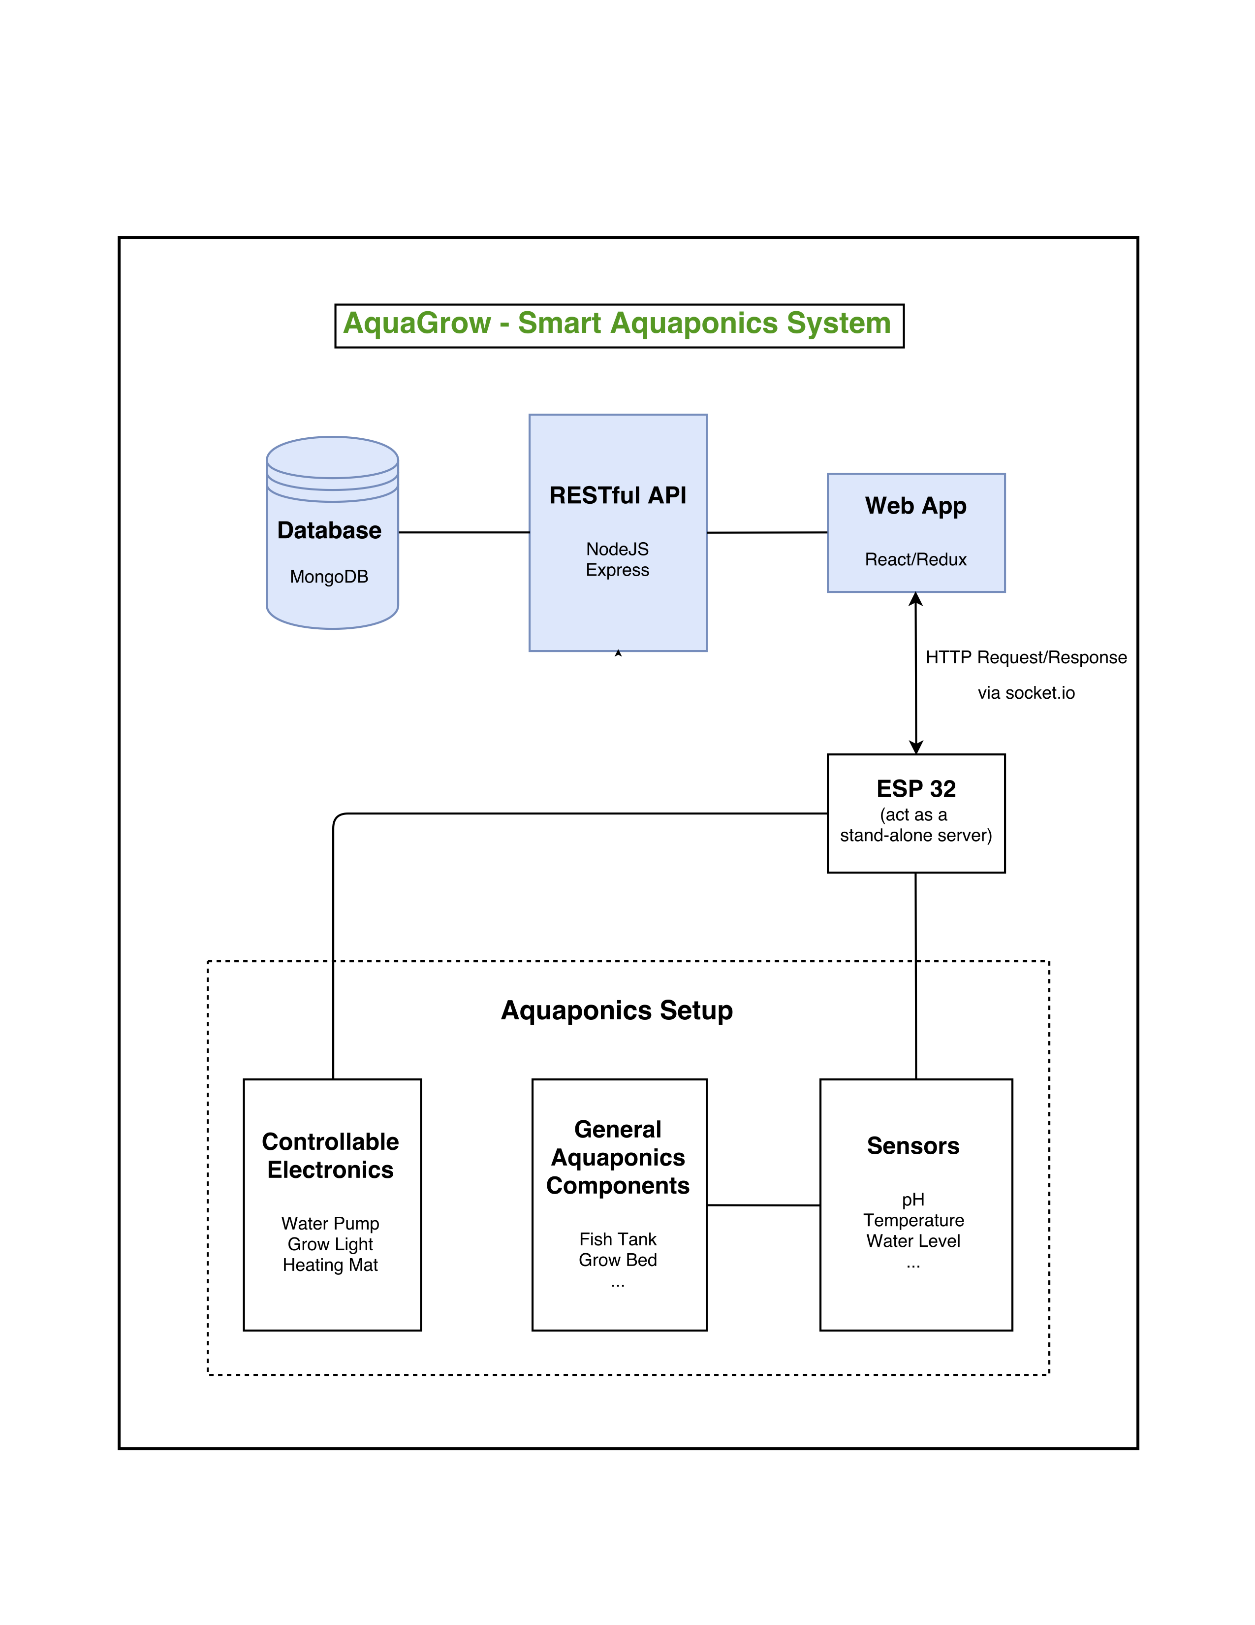

Diagram explanation:

* ESP32 directly controls the water pump, grow light and heating mat. It also directly obtains data from the sensors.
* ESP32 constantly sends HTTP POST requests containing sensor data to the web application. The web app would process the incoming data and act accordingly (if the accepted data is out of set range, the app should send out notifications to the users)
* The web application in turn sends HTTP POST requests to ESP32 containing data regarding user’s settings, such as how often the user wants to receive the sensor data or whether the user wants to turn anything on/off.
* Similarly, the API provide endpoints for the web application to send HTTP requests and communicate with the database.
  + *Side Note: the architecture might change in terms of whether ESP32 will communicate directly to the web application or via the API. It’s currently undecided how the application wants to store and keep track of the sensor data.*

Database Design:

* The database will include information regarding USDA Plant Hardiness Zones, plant presets (suggested temperature, water level, timeline, etc. for a particular plant), users’ information, users’ gardening portfolio, and potentially a large amount of sensor’s data for the creation of graphs that help show trends/consistencies of the system.
* The database design is currently not finished. However, the schema design and patterns will follow MongoDB official documentation and tutorials closely. Check out bibliography for MongoDB references.

**Implementation Strategies**

The implementation of the web application will focus on the use of MVC model. By using React as the front-end framework, many components will be reusable and Redux will help with managing the states of each component.

The application will also focus on having modular code base, which means that each functionality or component will be contained inside a JavaScript module.

**User Interfaces**

User interface will mainly consist of a dashboard. The dashboard will consist of all the real-time data from the sensors, list of the plant(s) that are being grown, and graphs that show data trend over time. Besides that, basics functionality such as signup, login, logout, settings will be provided. Detailed user interface design will be done with Sketch/Adobe XD.

**Test and Integration Plan**

The sensors will be tested individually first before being continuously added to the ESP32. The implementation of the hardware will be helped by Sandip Gautam, a student from Department of Electrical Engineering. While Sandip develops on the sensors + ESP32 system, the database, API and web application will be developed. Database and API endpoints will be tested by Postman. Application’s responsive web interface will be tested by Sizzy.

The whole application will be tested through the use of Travis CI, a continuous integration service used to test software projects hosted through GitHub. Every time a new commit of the source code is pushed to GitHub, Travis will automatically build the project, run the tests and deploy the application.

**Project Timeline**

* Wed, 2/21: Finished ordering all needed hardware
* Fri, 2/23: Finish database design
* Wed, 2/28: Finish mock UI design
* Wed, 3/7: Start testing out the ESP32 sensors and getting the data over HTTP requests
* Sun, 3/11: Finish creating main endpoints for the API. Test the API
* Sun, 3/18: Finalize database design, import dataset and create dummy data for API testing
* Sun, 3/25: Finish user authentication feature
* Wed, 3/28: Finalize on UI design, start on implementing the UI (without fetching real data)
* Wed, 4/4: Finish draft UI, start fetching with real data. If not able to fetch data from ESP32, come up with a simulation environment.
* Wed, 4/11: Integrate with Travis CI for continuous integration, start deploying to Heroku
* Sun, 4/15: Start finalizing on features and the application’s styling
* Wed, 4/22: Continue with touching up on features and styling. Focus on testing and simulation if still not able to fetch data from ESP32.
* Sat, 4/28: Start on documentation

**Bibliography**

* NodeJS official documentation: <https://nodejs.org/en/>
* Express guide and API reference: <https://expressjs.com>
* Facebook’s official ReactJS Docs: <https://reactjs.org/docs/hello-world.html>
* Redux’s Documentation: <https://redux.js.org>
* MongoDB architecture: <https://www.mongodb.com/mongodb-architecture>
* MongoDB schema design: <https://www.mongodb.com/blog/post/6-rules-of-thumb-for-mongodb-schema-design-part-1>
* MongoDB data model examples and patterns: <https://docs.mongodb.com/manual/applications/data-models/>
* Travis CI documentation: <https://docs.travis-ci.com>
* Ant Design: <https://github.com/websemantics/awesome-ant-design>
* ESP32 web server: <https://randomnerdtutorials.com/esp32-web-server-arduino-ide/>
* MERN stack: <http://mern.io>

**Minimum Viable Product**

The minimum viable product will include the following:

* A well-designed MongoDB database
* A RESTful API that provides all necessary endpoints to communicate with the database. The API would allow developers to make any application on any platform (web, cross-platform mobile app, desktop app…)
* A well-designed, mobile-responsive and dynamic web application that fulfills all the sponsor’s expected features. The web application would be able to at least fetch, process and respond to the sensor data from a simulation environment, in case the integration with the real aquaponics system is not successful.